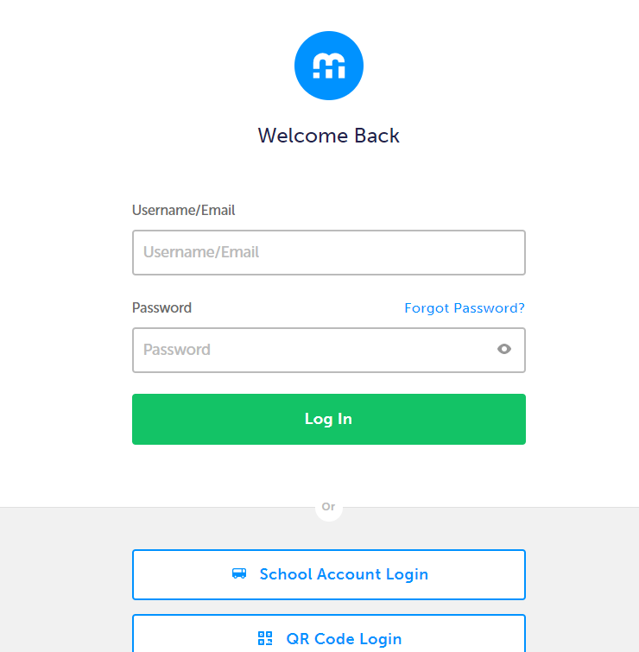
This step-by-step guide will help you complete online course selection using the myBlueprint website.
- EXISTING USER?

- Go to BHNCDSB website – www.bhncdsb.ca
- Select Register Tab.
- Select “ SECONDARY REGISTRATION”,
Then select MyBlueprintLink 
4) Login by selecting School Account Login, then select Brant Haldimand … and enter your BHNCDSB Username and Password. (If you are at school select School Account Login, then select Brant Haldimand and it will automatically sign you in)

- COURSE SELECTION
- From your Dashboard, click on High School from the left hand navigation menu.

- ADD COURSES FOR NEXT YEAR
  - In High School Planner, click + [Course].
  - From this screen you can explore the available courses.
  - Click Add Course when you find the course you want.
  - We ask that you choose an alternate course should one of your electives not be available.

HINT: The Graduation Indicator will help you keep track of your progress towards graduation. Click View Progress for a list of specific graduation requirements.
- IF YOU ARE CHOOSING SUMMER SCHOOL

- Please see the detailed instructions on the last page of this hand out

- REVIEW COURSES – When you are ready to submit your course selections, click the blue Review Course Selections button and give your course selection one final look over.
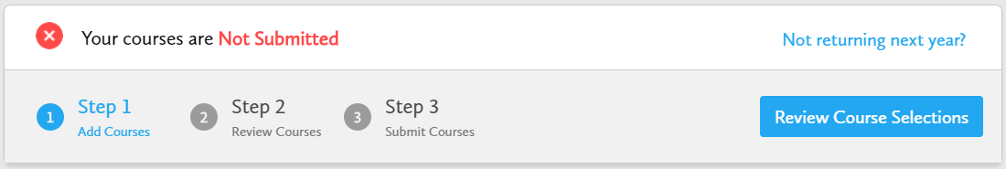

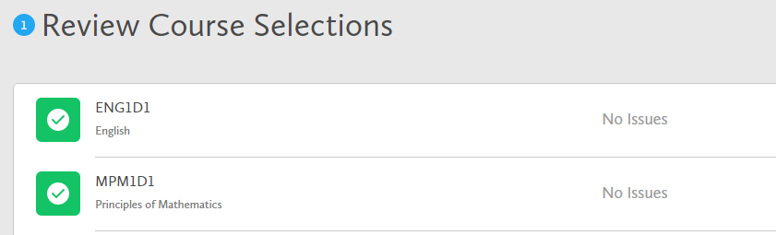

If available, you can use the “Add Comments” section to explain any issues to your guidance counsellor (i.e. taking the prerequisite in night school, or summer school)
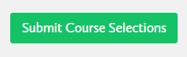
- SUBMIT COURSES – Once you’ve carefully reviewed the Details page to ensure that you are meeting the requirements for the courses you have selected and that the courses that appear are correct, click on Submit Course Selections. PLEASE NOTE THAT YOU WILL NOT BE ABLE TO MODIFY YOUR SELECTIONS ONCE YOU HIT SUBMIT!

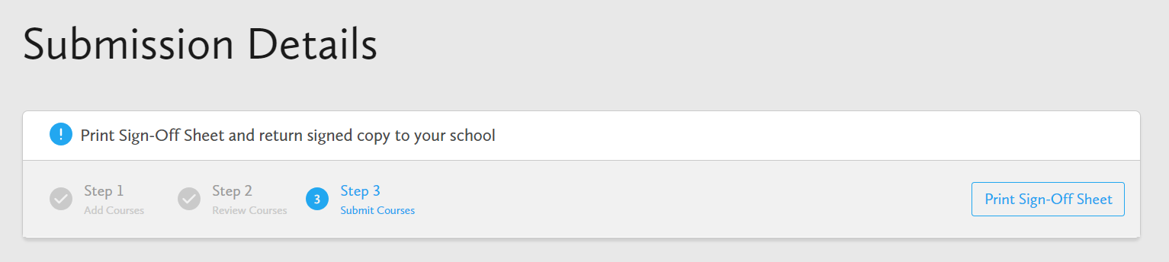

- If you receive a RED warning, please DO NOT CONTINUE. If the warning states that you have too many course selections, please go back and omit one. If the warning states that you do not have enough selections, please go back and add a course.

- PRINT SIGN –OFF SHEET – After submitting your course selections, click on the Print Sign-Off Sheet button at the top right.
THE SIGN OFF SHEET AND ACTIVITY FEE OF $55 IS DUE TO HT BY TUESDAY FEBRUARY 18TH. YOU MAY PAY BY SCHOOL CASH ONLINE (SUBMIT THE RECEIPT) OR CASH (IN AN ENVELOPE LABELLED WITH YOUR NAME) OR CHEQUE

NOTE: You can also access the sign-off sheet from the High School planner – if it doesn’t show after you’ve click the Print Sign-Off Sheet button, check the pop-up blocker settings for your web browser.

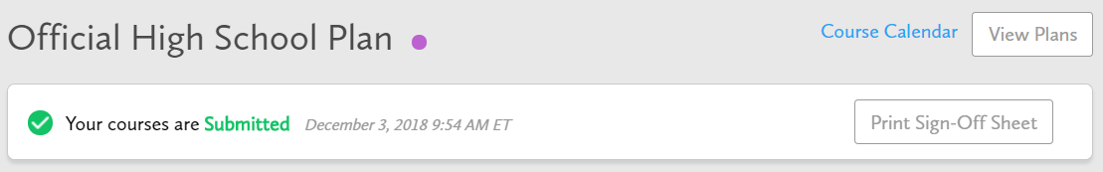

Not returning next year?
- From your Dashboard, click on the Not returning next year? button that appears in the High School Progress box.
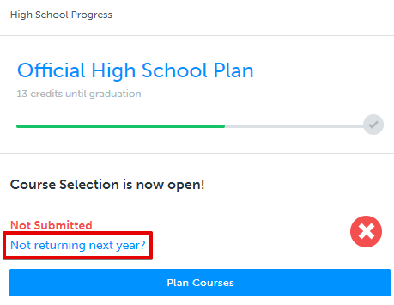

- Select the option that suits your pathway and press confirm
