Scholarship & Bursary Information Package – 2020/2021

Where do most students find $$?

At the college/University they attend. Each school has their own scholarships & awards. Some are entrance scholarships and may not require an application, others are prestigious awards that do require an application. Be sure to visit the website of the school you are interested in and check out the scholarships, bursaries, and financial aid available!

www.ontariouniversitiesinfo.ca – Research University programs, scholarships, residence & admission requirements
www.ontariocolleges.ca – Research College programs, scholarships and admission requirements
www.trinitycatholic.ca – search the Financing Your Education tab under STUDENT LIFE drop down menu
www.osca.ca/students/2013-11-07-18-12-28/scholarships-financial-aid.html
https://www.osap.gov.on.ca/OSAPSecurityWeb/public/login.xhtml
https://yconic.com; www.scholarshipscanada.com; www.univcan.ca/; www.scholartree.ca
www.canlearn.ca – online budget planner for post-secondary education. Follow financial planner
** Indicates scholarships which require a nomination from school. If interested, please fill out application (below) and submit to guidance by the indicated date

October
Horatio Agler Ontario Scholarship https://www.horatioalger.ca/en/scholarships
**Queen’s University Major Admission Award – Sponsored and Direct Pool applicants. https://www.queensu.ca/studentawards/admission-awards/major-admission-awards - submit application (below) to guidance by October 8th if interested in being considered for a nomination.
**National Scholarship Program (University of Toronto) – Sponsored and Direct Pool applicants. https://www3.adm.utoronto.ca/National/closed.php Submit application (below) to guidance by Oct 8th, to be considered

November
TD Canada Trust Scholarships for Community Leadership – http://www.tdcanadatrust.com/scholarship

December
**Western University National Scholarship Program – Submit application (below) to Guidance by Dec 10th to be considered - http://www.registrar.uwo.ca/student_finances/scholarships_awards/national_scholarship_program.html
**Schulich Leader Scholarship – www.schulichleaders.com Submit app (below) to Guidance by Dec. 3rd to be considered

February
Dr. Gordon C. Watts Memorial Arts Scholarship – www.simcoerotaryclub.com
Terry Fox Humanitarian Award - http://www.terryfoxawards.ca
Kin Canada Bursary - https://www.kincanada.ca/bursaries

March
Crime Stoppers Bursary - https://helpsolvecrime.com/william-robert-courtnage-community-bursary/
Scout Scholarship (Optimist) https://www.scouts.ca/programs/scholarships.html
HATCH McMaster Engineering Entrance Scholarship – www.eng.mcmaster.ca/future/schol.html
Norfolk District Women’s Institute – Leadership Award – see Guidance

April
Lieutenant Governor’s Community Volunteer Award –highest #of hours submitted by October 31st are selected as nominees
Petroleum Services Association of Canada - http://www.psac.ca/?s=scholarship
Aird Scholarship – http://www.canadian-universities.net/Scholarships/A/Aird-Scholarship.html
Simcoe and District Labour Council – 519.426.6028
Aberdeen Health & Community Services (Pharmacy) and (Nursing) – available in guidance
Libro Credit Union – www.libro.ca/studentawards
**Kilpatrick Scholarship - Norfolk students furthering their studies in a business related programs. Submit application (below) to guidance by April 12th to be considered
Ontario Hockey Federation – http://www.ohf.on.ca/ … AWARDS
OFSSA Alumni Scholarship - http://www.ofsaa.on.ca/programs/scholarships/ofsaa-alumni
Ontario Provincial Police Youth Foundation – https://www.lesapollos.ca/bourses/OPP_Youth_Foundation.pdf
**Wanda and Scott Salverda Memorial Scholarship – http://www.wandaandscottmemorial.ca Submit application (below) to guidance by April 12th to be considered
Chelsea Addison Memorial Bursary – entering field of study that involves mental health, or student who has suffered from a mental health challenge themselves. Due April 26th. Submit application (below) to guidance.
**David Biddle Memorial Scholarship – Due April 26^{th.} Submit application (below) to guidance.
**Gerrit Gubbels Memorial Scholarship – Due April 26th. Submit application (below) to guidance.
Smitiuch Injury Law Scholarship – applications available in guidance
Soroptimist International of Grand Erie (Female Norfolk Volunteer award) - http://www.soroptimistgranderie.ca/

May
Rotary Club of Simcoe Gordan Watts Scholarship – $1000.00 awarded to a student pursuing fine arts, including visual, arts, fine arts, graphics, art history, film, photography animation, webdesign, etc. https://simcoerotaryclub.com/306/Page/Show?ClassCode=Page&Slug=dr-gordon-c-watts-scholarship
Norfolk Historical Society (History) – https://www.norfolkhistoricalsociety.ca/
Knights of Columbus Bursary - https://ontariokofc.ca/programs/faith-in-action/community/bursary/
Federation of Portuguese Canadian Business and Professionals – http://www.fpcbp.com/ .
Norfolk Federation of Agriculture – See application below
Norfolk Potters’ Guild and Studio – for Norfolk students furthering their studies in a Visual Arts Program. See guidance.
**Father Fogarty Catholic Award (CEFO) – Submit application (below) to guidance by May 1st to be considered
Water Environment Association of Ontario - https://www.weao.org/kelman_scholarship_program - Kelman Scholarship
D.O.T.S. Bursary Scholarship – Norfolk student pursuing a career in the textile industry – see guidance for application
Richard Walker Memorial Scholarship Application – application available in guidance.
Robert Haworth Conservation Scholarship – awarded to students pursuing post-secondary education in a conservation, environment, resource/parks/wildlife management, planning or hydrology field of student. See guidance for more info.
Leighton & Betty Brown Conservation Scholarship – – (2) $1,000 scholarships will be awarded to graduating high school students who are programs related to conservation, environment, resources management and/or related program. More details at https://lprca.on.ca/education-programming/scholarship/
Ontario Justice Education Network Bursary - http://bit.ly/OJENBursaries
June
Norfolk Soil & Crop Improvement Association Scholarship – (2) $500 scholarships in 2021 to graduating high school students who will be entering first year of full-time, undergraduate study in university or college in Agriculture or Environment related field. Application below.
Ralph Bradley Memorial Scholarship – (agriculture/water management) – https://notl.civicweb.net/document/13710
The OTIP Bursary program - https://www.otip.com/bursary
July
Johnson Insurance Scholarship Program - https://www.johnson.ca/scholarship
Roger Cruickshank Scholarship: $2500 – student must live in Vittoria and District and entering post-secondary program in Sept: http://www.vittoria.on.ca/pdfs/Scholarship2019.pdf

Queen’s University Major Admission Award– for SPONSORED applicants

https://www.queensu.ca/studentawards/admission-awards/major-admission-awards

Description of Award:
Students who demonstrate superior academic ability (cumulative average of 90% (or equivalent) or greater throughout high school), original and creative thinking, involvement in school or community activities, and proven leadership qualities may apply for a major admission award. Financial need is also a consideration for some of our major admission awards.

Holy Trinity can nominate ONE student for the Queen’s University CHANCELLOR scholarship.

If you would like to be considered for this prestigious award, please submit a ONE PAGE summary to Guidance ON or BEFORE October 8th, 2020. This ONE PAGE summary will highlight how you best meet the criteria (description) for this prestigious award.
There are a number of Major Scholarships from Queen’s university that do NOT require a school nomination. Be sure to check out the link above to see if you qualify. Remember the deadline is DEC 1st, 2020

Application: Due to guidance by October 8th, 2020
Please complete a 1-page summary outlining how you meet the criteria as highlighted above.

Page Break
National Scholarship Program (University of Toronto) Book Award – for SPONSORED applicants

Description of Award:
The University of Toronto National Book Award Program recognizes and rewards the very best Canadian secondary school students, regardless of which university those students choose to attend. These are students who demonstrate superior academic performance, original and creative thought, and exceptional achievement in a broad context. They excel in academic pursuits, demonstrate enthusiasm for intellectual exploration and have a strong involvement in the lives of their schools and communities. It is not necessary that the student intend to apply for admission to the University of Toronto.
Award recipients receive a National Book Award recognizing their achievements, and as a symbol of their academic potential. It is a non-monetary award. The book will be presented to the student at their secondary school graduation ceremony at the end of the school year. Students nominated for this award are invited to submit an application to the National Scholarship Program.

If you would like to be considered for the University of Toronto National Book Award and Scholarship Program, please fill out the application below and submit to guidance (Ms. Deroo) by October 8TH, 2020.

Application: Due to guidance by Oct 8th, 2020
Please complete a 1-2-page summary outlining how you meet the criteria as highlighted above.

Western University National Scholarship Program– for SPONSORED applicants

Description of Award:
National Scholarships are designed to recognize all-round excellence. They are awarded on basis of outstanding academic performance to candidates who demonstrate ability for creative and innovative thought and a passion for the pursuit of learning. National Scholarships also recognize exceptional achievement in extracurricular activities such as the arts and athletics. A special emphasis is placed on a candidate's commitment to community service.

Holy Trinity can nominate FOUR (4) students as a Western National Scholarship nominee. If you would like to be considered for the award, Guidance is requesting that you submit a ONE PAGE summary to Guidance ON or BEFORE December 10th, 2020.

Application: Due to guidance by December 10th, 2020
Please complete a 1-page summary outlining how you meet the criteria of a National Scholar.

Schulich Leader Scholarship – for SPONSORED applicants

www.schulichleaders.com

Description of Award:
Nominees must possess at least two of three criteria:
1. Academic Excellence
2. Outstanding community, business or entrepreneurial leadership
3. Financial need
Nominees must be enrolling in a Science, Technology, Engineering or Math (STEM) degree at one of our partner universities.

Holy Trinity can nominate ONE student as a SCHULICH LEADER nominee. If you are interested in being considered for this award, Guidance is requesting that you submit a ONE PAGE summary to Guidance BEFORE December 3rd, 2020

Application: Due to guidance by December 3rd, 2020
Please complete a 1-2-page summary answering the question “Why would I make a good SCHULICH Leader?”

Kilpatrick Scholarship

Eligibility requirements:
- A student enrolled in a Haldimand/Norfolk secondary school who will be furthering their students in a business related program at the post-secondary level
- Student must have attended the same school for three years
- The candidate must be pursuing a post-secondary education in a school in the current year of graduation.

Criteria:
- Candidate must be active in school
- Candidate must be pursuing a post-secondary education (in a business-related program) in the September of the year they graduate.
- Candidate should demonstrate the financial need for this scholarship
- Candidate must be active in the community
- Candidate must exemplify a solid work ethic in their everyday lives

Holy Trinity can nominate ONE (1) student as a Kilpatrick nominee. If you would like to be considered for the award, Guidance is requesting that you submit a ONE PAGE summary to Guidance ON or BEFORE April 12th, 2021

Application: Due to guidance by April 12th, 2021
Please complete a 1-2-page summary outlining how you meet the criteria of the Kilpatrick Scholarship.

Wanda & Scott Salverda Memorial Scholarship

Eligibility requirements:
A student enrolled in a Haldimand/Norfolk secondary school
Student must have attended the same school for three years
The candidate must be pursuing a post-secondary education in a school in the current year of graduation.

Criteria:
- Candidate must be active in school
- Candidate must be pursuing a post-secondary education in the September of the year they graduate.
- Candidate should demonstrate the financial need for this scholarship
- Candidate must be active in the community
- Candidate must exemplify a solid work ethic in their everyday lives
- The successful candidate must be willing to volunteer at the annual Wanda & Scott Memorial Golf tournament

Holy Trinity can nominate ONE (1) student as a Salverda nominee. If you would like to be considered for the award, Guidance is requesting that you submit a ONE PAGE summary to Guidance ON or BEFORE April 12th, 2021

Application: Due to guidance by April 12th, 2021
Please complete a 1-2-page summary outlining how you meet the criteria as highlighted

The Catholic Student (CEFO) Father Fogarty Award

Eligibility requirements:
- Selection should recognize good scholarship, involvement in school or community activities, and conduct which typifies the objectives of the Catholic school;
- Emphasis is to be placed more on activities not usually formally recognized in the school (such as year book, student council, drama, mission drives, leadership in social concerns, etc.)
- Consideration should be given to involvement in projects that enhance the identity of the Catholic school in the local community, volunteer work in the community, local hospitals, parishes, with youth corps, senior citizens, persons with disabilities; on political or social issues, or with other projects of a similar kind.

Holy Trinity can nominate ONE (1) student as a CEFO nominee. If you would like to be considered for the award, Guidance is requesting that you submit a ONE PAGE summary to Guidance ON or BEFORE May 1st, 2021

Application: Due to guidance by May 1st, 2021
Please complete a 1-2-page summary outlining how you meet the criteria as highlighted

Chelsea Addison Memorial Bursary (Page 1 of 3)
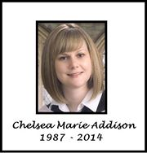
This bursary was created to honour and remember the life of a wonderful young Norfolk County resident named Chelsea Addison, whose life was tragically cut short by mental illness. After battling anxiety and depression throughout her teen and adult years, Chelsea died by suicide at the age of 26.
This bursary is funded and organized by Norfolk Rotaract, with the help of the CAMHS Wellness & Recovery Centre.
OBJECTIVE
By offering this bursary, we hope to help end the stigma surrounding mental illness, bring about mental health awareness in our community and hopefully engage young people and others in this very important conversation.
"It is not so much that suicide is hidden, but that we hide it. Denial and avoidance are barriers to suicide prevention." - from the 'Suicide; Facts, Tips and Resources' handbook developed and distributed by the Haldimand-Norfolk Resource Centre.

QUALIFICATIONS
The Chelsea Addison Memorial Bursary will be awarded to one student aged 21 and under (as of December 31, 2019) in either Haldimand or Norfolk County each year. To qualify for this bursary, an applicant must have applied to a post secondary program and either;
• Be entering into a post secondary program with a focus on the field of treating and/or studying mental health.
-Or-
• Be someone who has personally dealt with a mental health challenge. A mental health challenge can be defined as anything that has contributed to a decline in mental health for the applicant (trauma, bereavement, addiction or illness affecting the applicant can all be defined as mental health challenges) Because one objective of this scholarship is to remove the stigma that surrounds discussing mental health, applicants must feel comfortable with receiving the award at their graduation ceremony. No personal details of their story will be shared during the presentation without their explicit permission.
Please note selection will not be based on grade point average or extra-curricular activities though they may be included in your essay.
The bursary will not be awarded to the selected candidate without proof of acceptance to their program. Proof such as a class schedule will be required.

Chelsea Addison Memorial Bursary (Page 2 of 3)
HOW TO APPLY
Students wishing to apply for the Chelsea Addison Memorial Bursary are asked to send a personal essay along with their application form to the Norfolk Rotaract Club – Bursary Selection Committee. Completed application packages should be sent to rotaractbursary@gmail.com or dropped off at your school guidance department.
BURSARY AWARD
One (1) student chosen to receive the Chelsea Addison Memorial Bursary will be awarded with a cheque of between $500 and $1000 and have their name engraved on a plaque which will be displayed in their high school during the following school year. Final award amount will be decided once all bursary funds are calculated.

Please know that if you are thinking about dying by suicide, you are not alone. Talk to a friend, a family member or reach out to the resources we have in our community that are listed below. You matter. Please do not suffer in silence.

Haldimand-Norfolk Community Resources
- 911 for any immediate risk
- Norfolk General Hospital 519-426-0130
- West Haldimand Hospital 905-768-3311
- Haldimand War Memorial 905-774-7431
- CAST (Crisis Assessment & Support Team) 1-866-487-2278 for mental health crisis 24/7 phone line
- Walk in counselling REACH 1-800-265-8087
- REACH - Child and Youth Services 1-866-327-3224 24/7 phone line
- CAMHS (Community Addiction & Mental Health Services) 1-877-909-4357
- CMHA (Canadian Mental Health Association) 1-888-750-7778
- Family doctor or walk in clinic
For additional resources and information, please contact the CAMHS Wellness & Recovery at 519-428-0580 or like them on Facebook - httpshttps://www.facebook.com/CAMHSWRC/
Any questions about the bursary or the application process can be made by e-mailing rotaractbursary@gmail.com or by calling Jason Schram at 226-931-0970.

Chelsea Addison Memorial Bursary Application Form
Applicant Information:
Name: ___________________________________________ Date of Birth: ________________________
Address: _____________________________________________________________________________
E-mail Address:______________________________________ Phone Number: ____________________
Which method of contact do you prefer? Phone: E-mail: Other (please specify): _______________
May we contact you using the following methods? Please don't hesitate to say no to any methods. We would like to communicate in the way that makes you most comfortable.
Phone: YES/NO E-mail: YES/No Other: ______________________________________________________
Highschool(s) Attended: ___________________________ Year of Graduation: _________
Please list what school(s) and program(s) you have applied to:
School:_____________________________________ Program: _________________________________
School:_____________________________________ Program: _________________________________
School:_____________________________________ Program: _________________________________
School:_____________________________________ Program: _________________________________

Personal Essay
Please attach your personal essay to your application. The personal essay should be 500-2000 words based on one or more of the topics below:
• A personal account of how a mental health challenge has impacted your life and how it has affected you. Include details on how you have handled and dealt with this, either personally or with the help of a professional.
• What post secondary institution and program are you entering and what are your goals upon completion of your program?
• What made you decide to apply for this scholarship? In what ways do you feel you would benefit if you are chosen to receive this award?
• What actions could we take, either on a personal level or as a society, to remove the stigma surrounding mental illness and discussing mental health?

DEADLINE to apply: Applications must be received on or before May 25th each year.
The David Biddle Memorial Scholarship
The David Biddle Memorial Scholarship has been established by contributions of family and friends to honour the memory of David Biddle. The scholarship is awarded annually to a graduating student who is recognized by both students and staff for optimism and energy, for freely expressing care, kindness, compassion and support to other students, and for enthusiastic involvement in school life. The student will have a good academic standing at the academic or applied level. The scholarship will be paid against tuition fees at a university or post-secondary institution of the student’s choice. (Proof of acceptance and attendance must be provided to Student Services, Holy Trinity Catholic High School for release of these funds by October 1st in the year of study.)
To assist us in selecting a candidate, please complete this form and hand it in (e-mail to mburnie@bhncdsb.ca) to Student Services no later than April 26, 2021
STUDENT NAME: _____________________________________
NOTE: Attach a copy of your school transcript to the application.
1. Give specific examples of how you have shown the following during your school years at Holy Trinity. (Please use reverse side if additional space is required)
a) Compassion & support towards other students
_______________________________________________________________________________________________________________________________________________________________________________________________________________________________________________________________________________________________________________________________________________
b) Kindness
________________________________________________________________________________________________________________________________________________________________________________________________________________________________________________________________________________________________________________________________________________
c) Optimism & energy
________________________________________________________________________________________________________________________________________________________________________________________________________________________________________________________________________________________________________________________________________________
2. List your academic awards received at Holy Trinity.
____________________________________________________________________________________________________________________________________________________________________________________________________________________________________________________________
3. List your school involvement at Holy Trinity.
________________________________________________________________________________________________________________________________________________________________________________________________________________________________________________________________________________________________________________________________________________

Application for the Gerrit Gubbels Memorial Scholarship


About the Scholarship:
The Gerrit Gubbels Memorial Scholarship is a memorial in honour of Gerrit’s 17 years; and his passion towards the arts, in particular Theatre Arts. He valued compassion and kindness towards others. He was active and trained within the school drama program, Simcoe Little Theatre, Port Dover Lighthouse Theatre, Waterford Old Town Hall and attended the Stratford Theatre School. His dream was to one day live in New York City and perform on Broadway.
Eligibility Requirements:
To be eligible for the scholarship, the applicant must be a Holy Trinity student who is pursuing a full-time post-secondary school education in either a University or a College program. Demonstration of involvement within theatre arts is preferential but not mandatory. Examples within the theatre arts could include: lighting, stage set-up, program development and/or design of program cover, ushering, selling tickets, dancing, singing, playing a musical instrument, script writing, acting or production. The scholarship will be awarded based on the strength of the candidates’ artistic background and sensitivity towards others; in the spirit of Gerrit.
Payment of the Scholarship:
If chosen as the recipient of the scholarship, proof of acceptance and enrolment must be provided to Student Services, Holy Trinity Catholic High School for release of these funds in the month of October in the first year of study. The scholarship will be paid against tuition fees at a university or college of the student’s choice.
Requirements:
Fully complete the following questions, if additional room is required use #7 or attach a separate paper:
- Student Name: ______________________________________________
- Briefly describe your plans after high school: ____________________________________________________________________________
Please continue to page -2- on back
- Please tell us what being awarded this scholarship would mean to you:_________________________________________________________________________________________________________________________________________________________________________________________________________________________________________________ ___________________________________________________
- Considering school, work, volunteering, home or an extracurricular activity; please outline your experiences with the arts, particularly theatre arts: _______________________________________________________________________________________________________________________________________________________________________________________________________________________________________________________________________________________________________
- What challenging or compelling experience makes you a unique scholarship recipient? ________________________________________________________________________________________________________________________________________________________________________________________________________________________________________________________________________________________________________
- Provide details about your primary personality trait and how it has guided you throughout your life. Include an example about how it has helped you through challenging situations, as well as how it has helped others. ________________________________________________________________________________________________________________________________________________________________________________________________________________________________________________________________________________________________________________
- Additional information: ________________________________________________________________________________________________________________________________________________________
Good Luck and thank-you for applying to the Gerrit Gubbels Memorial Scholarship!
Please email the one page summary to mburnie@bhncdsb.ca by April 26th, 2020
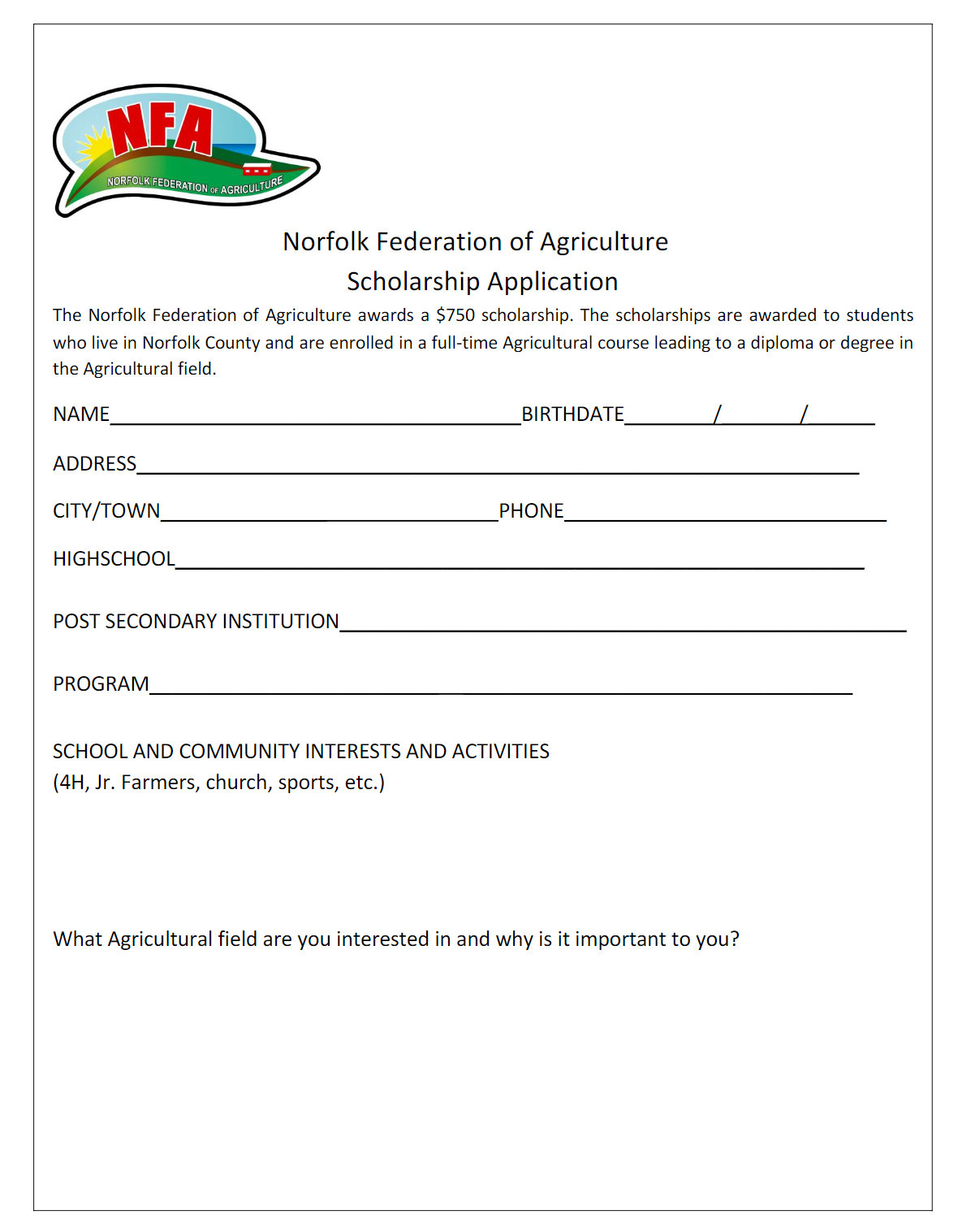
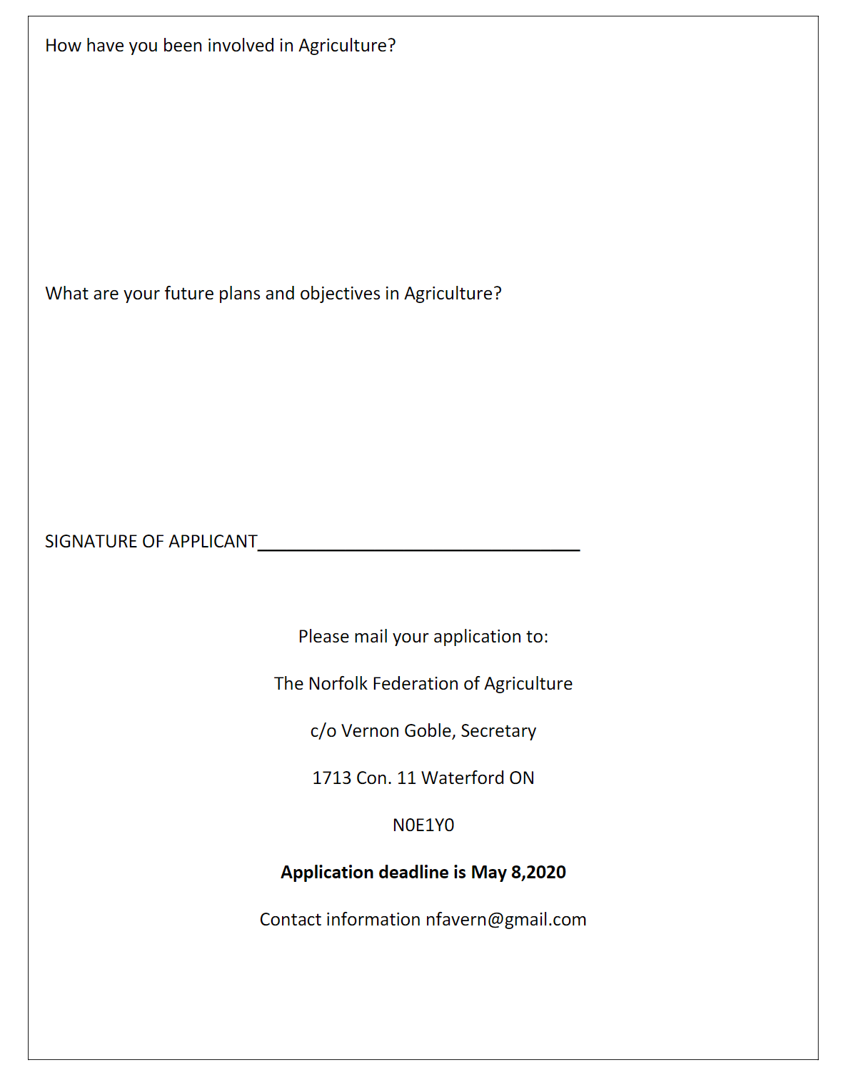

Norfolk Soil and Crop Improvement Association Scholarship

The Ontario Soil and Crop Improvement Association is a unique non-profit farm organization that represents all commodity groups across the province. There are 53 local county associations making up the OSCIA’s network of innovative producers.
Our mission statement is: “Facilitate responsible economic management of soil, water, air and crops through development and communication of innovative farming practices”.
The Norfolk Soil and Crop Improvement Association will award two (2) $500 scholarships in 2021 to graduating high school students currently residing in Norfolk County. The scholarships are awarded to students who will be entering first year of full-time, undergraduate study in university or college in Agriculture or Environment related field.

Applicant Information
Name: ____________________________________________________
Address: ___________________________________________________
City/Town: _________________________________________________
Postal Code: _______________ Phone: __________________________
Email: _______________________________________
High School Currently Attending: _______________________________
Academic Average
Grade 11 Final Grade %_____ Grade 12 Semester 1 Grade %_____
Post-Secondary Institution*: ___________________________________
Program of Study: ___________________________________________
*Please attach copy of university/college acceptance letter
Please provide a written summary for the selection committee in 500 words or less answering the following questions;
- Please describe your current involvement in Agriculture and the community.

- Why do you want receive an education in this field and what do you hope to do with this acquired knowledge upon graduation?

I understand and agree that:
- If I am selected as a scholarship recipient, my name and photograph may be released and used for publicity purposes associated with the Norfolk Soil and Crop Improvement Association.
- A selection committee will review all submitted applications and select the scholarship recipients. The committees’ decision is final.
Signature of Applicant: ______________________________________
Date: _____________________________________

Applications (written summary, copy of acceptance letter and this form) must be received by June 25, 2021.
By mail:
Norfolk Soil and Crop Improvement Association
c/o Ann Vermeersch
455 Goshen Road
Tillsonburg, Ontario, N4G 4G7
By email:
Email: ann@tillvalleyfarms.com
Winners will be contacted by July 30, 2021. Awards will be presented at the NSCIA Directors Summer event, to which the recipients and their parents will be invited to attend. The location will be in Norfolk County (date and time TBD).

