Scholarship & Bursary Information Package – 2019/2020

Attention Graduating Students.
Due to COVID-19 Pandemic, there have been several changes to the scholarships that are posted; for example, the process of submitting or deadlines may be different. Follow instructions carefully.

April
The Vittoria & District Foundation Scholarship Program – http://www.vittoria.on.ca/scholarship.htm - link it as the bottom
Petroleum Services Association of Canada - http://www.psac.ca/?s=scholarship
Simcoe and District Labour Council – 519.426.6028
Libro Credit Union – www.libro.ca/studentawards
Ontario Hockey Federation – http://www.ohf.on.ca/ … AWARDS
OFSSA Alumni Scholarship - http://www.ofsaa.on.ca/programs/scholarships/ofsaa-alumni
Ontario Provincial Police Youth Foundation – https://www.lesapollos.ca/bourses/OPP_Youth_Foundation.pdf
Soroptimist International of Grand Erie (Female Norfolk Volunteer award) - http://www.soroptimistgranderie.ca/

May
Gordan Watts - https://simcoerotaryclub.com/306/Page/Show?ClassCode=Page&Slug=dr-gordon-c-watts-scholarship
Norfolk Historical Society (History) – https://www.norfolkhistoricalsociety.ca/
Chelsea Addison Memorial Bursary – See application below.
David Biddle Memorial Scholarship – See application below
Knights of Columbus Bursary - https://ontariokofc.ca/programs/faith-in-action/community/bursary/
Federation of Portuguese Canadian Business and Professionals – http://www.fpcbp.com/
Norfolk Federation of Agriculture – See Below
Water Environment Association of Ontario - https://www.weao.org/kelman_scholarship_program - Kelman Scholarship
Gerrit Gubbels Memorial Scholarship – See Application Below
Leighton & Betty Brown Conservation Scholarship – – http://www.lprca.on.ca 519.428.4623
Ontario Justice Education Network Bursary - http://bit.ly/OJENBursaries

June
Norfolk Soil & Crop Improvement Association Scholarship – (Agriculture/environmental) – See application below
Ralph Bradley Memorial Scholarship – (agriculture/water management) – https://notl.civicweb.net/document/13710
The OTIP Bursary program - https://www.otip.com/bursary

July
National Union Scholarships - https://nupge.ca/content/national-unions-scholarship-program-2018
Johnson Insurance Scholarship Program - https://www.johnson.ca/scholarship
Chelsea Addison Memorial Bursary (Page 1 of 3)
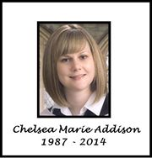
This bursary was created to honour and remember the life of a wonderful young Norfolk County resident named Chelsea Addison, whose life was tragically cut short by mental illness. After battling anxiety and depression throughout her teen and adult years, Chelsea died by suicide at the age of 26.
This bursary is funded and organized by Norfolk Rotaract, with the help of the CAMHS Wellness & Recovery Centre.
OBJECTIVE
By offering this bursary, we hope to help end the stigma surrounding mental illness, bring about mental health awareness in our community and hopefully engage young people and others in this very important conversation.
"It is not so much that suicide is hidden, but that we hide it. Denial and avoidance are barriers to suicide prevention." - from the 'Suicide; Facts, Tips and Resources' handbook developed and distributed by the Haldimand-Norfolk Resource Centre.

QUALIFICATIONS
The Chelsea Addison Memorial Bursary will be awarded to one student aged 21 and under (as of December 31, 2019) in either Haldimand or Norfolk County each year. To qualify for this bursary, an applicant must have applied to a post secondary program and either;
• Be entering into a post secondary program with a focus on the field of treating and/or studying mental health.
-Or-
• Be someone who has personally dealt with a mental health challenge. A mental health challenge can be defined as anything that has contributed to a decline in mental health for the applicant (trauma, bereavement, addiction or illness affecting the applicant can all be defined as mental health challenges) Because one objective of this scholarship is to remove the stigma that surrounds discussing mental health, applicants must feel comfortable with receiving the award at their graduation ceremony. No personal details of their story will be shared during the presentation without their explicit permission.
Please note selection will not be based on grade point average or extra-curricular activities though they may be included in your essay.
The bursary will not be awarded to the selected candidate without proof of acceptance to their program. Proof such as a class schedule will be required.

Chelsea Addison Memorial Bursary (Page 2 of 3)
HOW TO APPLY
Students wishing to apply for the Chelsea Addison Memorial Bursary are asked to send a personal essay along with their application form to the Norfolk Rotaract Club – Bursary Selection Committee. Completed application packages should be sent to rotaractbursary@gmail.com or dropped off at your school guidance department.
BURSARY AWARD
One (1) student chosen to receive the Chelsea Addison Memorial Bursary will be awarded with a cheque of between $500 and $1000 and have their name engraved on a plaque which will be displayed in their high school during the following school year. Final award amount will be decided once all bursary funds are calculated.

Please know that if you are thinking about dying by suicide, you are not alone. Talk to a friend, a family member or reach out to the resources we have in our community that are listed below. You matter. Please do not suffer in silence.

Haldimand-Norfolk Community Resources
- 911 for any immediate risk
- Norfolk General Hospital 519-426-0130
- West Haldimand Hospital 905-768-3311
- Haldimand War Memorial 905-774-7431
- CAST (Crisis Assessment & Support Team) 1-866-487-2278 for mental health crisis 24/7 phone line
- Walk in counselling REACH 1-800-265-8087
- REACH - Child and Youth Services 1-866-327-3224 24/7 phone line
- CAMHS (Community Addiction & Mental Health Services) 1-877-909-4357
- CMHA (Canadian Mental Health Association) 1-888-750-7778
- Family doctor or walk in clinic
For additional resources and information, please contact the CAMHS Wellness & Recovery at 519-428-0580 or like them on Facebook - httpshttps://www.facebook.com/CAMHSWRC/
Any questions about the bursary or the application process can be made by e-mailing rotaractbursary@gmail.com or by calling Jason Schram at 226-931-0970.

Chelsea Addison Memorial Bursary Application Form
Applicant Information:
Name: ___________________________________________ Date of Birth: ________________________
Address: _____________________________________________________________________________
E-mail Address:______________________________________ Phone Number: ____________________
Which method of contact do you prefer? Phone: E-mail: Other (please specify): _______________
May we contact you using the following methods? Please don't hesitate to say no to any methods. We would like to communicate in the way that makes you most comfortable.
Phone: YES/NO E-mail: YES/No Other: ______________________________________________________
Highschool(s) Attended: ___________________________ Year of Graduation: _________
Please list what school(s) and program(s) you have applied to:
School:_____________________________________ Program: _________________________________
School:_____________________________________ Program: _________________________________
School:_____________________________________ Program: _________________________________
School:_____________________________________ Program: _________________________________

Personal Essay
Please attach your personal essay to your application. The personal essay should be 500-2000 words based on one or more of the topics below:
• A personal account of how a mental health challenge has impacted your life and how it has affected you. Include details on how you have handled and dealt with this, either personally or with the help of a professional.
• What post secondary institution and program are you entering and what are your goals upon completion of your program?
• What made you decide to apply for this scholarship? In what ways do you feel you would benefit if you are chosen to receive this award?
• What actions could we take, either on a personal level or as a society, to remove the stigma surrounding mental illness and discussing mental health?

DEADLINE to apply: Applications must be received on or before May 25th each year.
The David Biddle Memorial Scholarship
The David Biddle Memorial Scholarship has been established by contributions of family and friends to honour the memory of David Biddle. The scholarship is awarded annually to a graduating student who is recognized by both students and staff for optimism and energy, for freely expressing care, kindness, compassion and support to other students, and for enthusiastic involvement in school life. The student will have a good academic standing at the academic or applied level. The scholarship will be paid against tuition fees at a university or post-secondary institution of the student’s choice. (Proof of acceptance and attendance must be provided to Student Services, Holy Trinity Catholic High School for release of these funds by October 1st in the year of study.)
To assist us in selecting a candidate, please complete this form and hand it in (e-mail to mburnie@bhncdsb.ca) to Student Services no later than May 15, 2020
STUDENT NAME: _____________________________________
NOTE: Attach a copy of your school transcript to the application. Not required for 2020
1. Give specific examples of how you have shown the following during your school years at Holy Trinity. (Please use reverse side if additional space is required)
a) Compassion & support towards other students
_______________________________________________________________________________________________________________________________________________________________________________________________________________________________________________________________________________________________________________________________________________
b) Kindness
________________________________________________________________________________________________________________________________________________________________________________________________________________________________________________________________________________________________________________________________________________
c) Optimism & energy
________________________________________________________________________________________________________________________________________________________________________________________________________________________________________________________________________________________________________________________________________________
2. List your academic awards received at Holy Trinity.
____________________________________________________________________________________________________________________________________________________________________________________________________________________________________________________________
3. List your school involvement at Holy Trinity.
________________________________________________________________________________________________________________________________________________________________________________________________________________________________________________________________________________________________________________________________________________

Application for the Gerrit Gubbels Memorial Scholarship


About the Scholarship:
The Gerrit Gubbels Memorial Scholarship is a memorial in honour of Gerrit’s 17 years; and his passion towards the arts, in particular Theatre Arts. He valued compassion and kindness towards others. He was active and trained within the school drama program, Simcoe Little Theatre, Port Dover Lighthouse Theatre, Waterford Old Town Hall and attended the Stratford Theatre School. His dream was to one day live in New York City and perform on Broadway.
Eligibility Requirements:
To be eligible for the scholarship, the applicant must be a Holy Trinity student who is pursuing a full-time post-secondary school education in either a University or a College program. Demonstration of involvement within theatre arts is preferential but not mandatory. Examples within the theatre arts could include: lighting, stage set-up, program development and/or design of program cover, ushering, selling tickets, dancing, singing, playing a musical instrument, script writing, acting or production. The scholarship will be awarded based on the strength of the candidates’ artistic background and sensitivity towards others; in the spirit of Gerrit.
Payment of the Scholarship:
If chosen as the recipient of the scholarship, proof of acceptance and enrolment must be provided to Student Services, Holy Trinity Catholic High School for release of these funds in the month of October in the first year of study. The scholarship will be paid against tuition fees at a university or college of the student’s choice.
Requirements:
Fully complete the following questions, if additional room is required use #7 or attach a separate paper:
- Student Name: ______________________________________________
- Briefly describe your plans after high school: ____________________________________________________________________________
Please continue to page -2- on back
- Please tell us what being awarded this scholarship would mean to you:_________________________________________________________________________________________________________________________________________________________________________________________________________________________________________________ ___________________________________________________
- Considering school, work, volunteering, home or an extracurricular activity; please outline your experiences with the arts, particularly theatre arts: _______________________________________________________________________________________________________________________________________________________________________________________________________________________________________________________________________________________________________
- What challenging or compelling experience makes you a unique scholarship recipient? ________________________________________________________________________________________________________________________________________________________________________________________________________________________________________________________________________________________________________
- Provide details about your primary personality trait and how it has guided you throughout your life. Include an example about how it has helped you through challenging situations, as well as how it has helped others. ________________________________________________________________________________________________________________________________________________________________________________________________________________________________________________________________________________________________________________
- Additional information: ________________________________________________________________________________________________________________________________________________________
Good Luck and thank-you for applying to the Gerrit Gubbels Memorial Scholarship!
Please email the one page summary to mburnie@bhncdsb.ca by May 31st, 2020
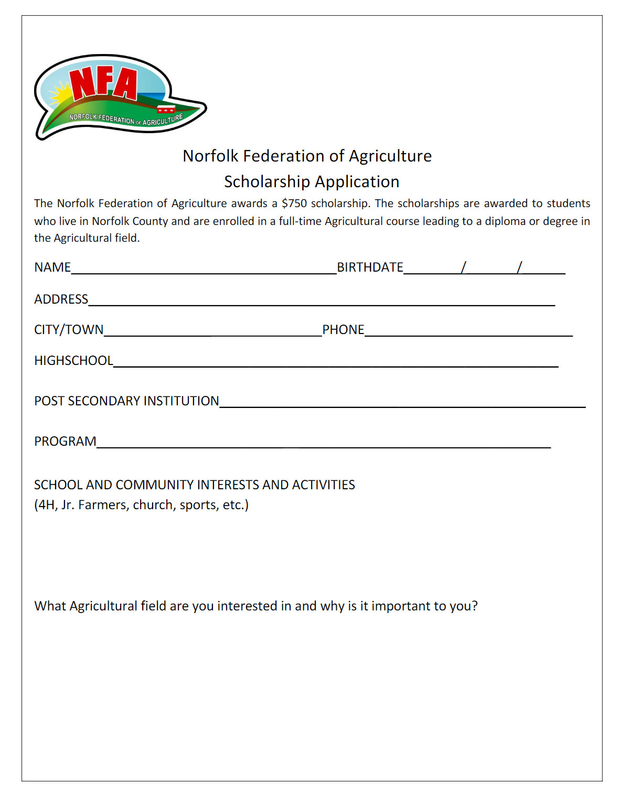
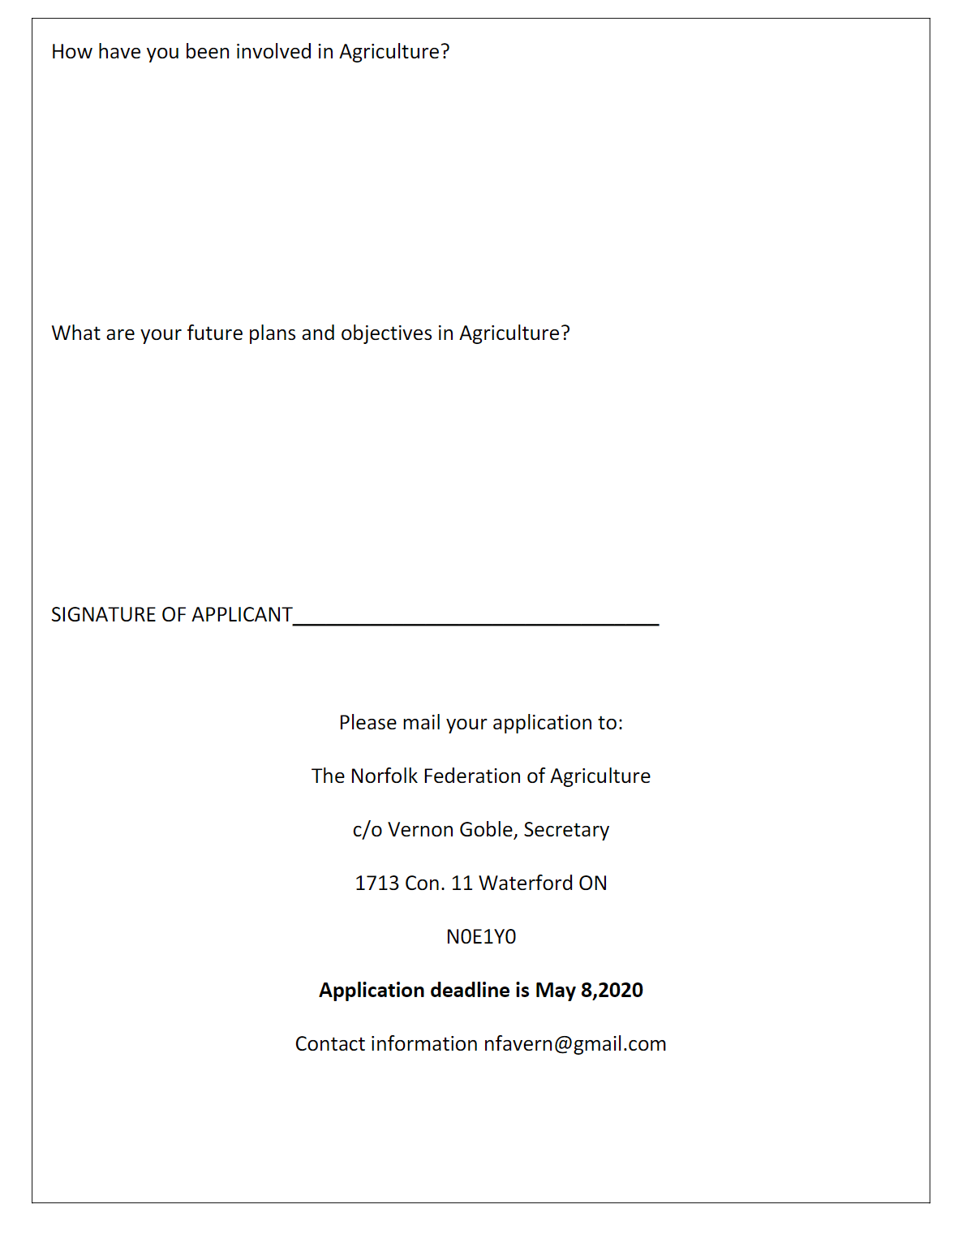

Norfolk Soil and Crop Improvement Association Scholarship

The Ontario Soil and Crop Improvement Association is a unique non-profit farm organization that represents all commodity groups across the province. There are 53 local county associations making up the OSCIA’s network of innovative producers.
Our mission statement is: “Facilitate responsible economic management of soil, water, air and crops through development and communication of innovative farming practices”.
The Norfolk Soil and Crop Improvement Association will award two (2) $500 scholarships in 2020 to graduating high school students currently residing in Norfolk County. The scholarships are awarded to students who will be entering first year of full-time, undergraduate study in university or college in Agriculture or Environment related field.

Applicant Information
Name: ____________________________________________________
Address: ___________________________________________________
City/Town: _________________________________________________
Postal Code: _______________ Phone: __________________________
Email: _______________________________________
High School Currently Attending: _______________________________
Academic Average
Grade 11 Final Grade %_____ Grade 12 Semester 1 Grade %_____
Post-Secondary Institution*: ___________________________________
Program of Study: ___________________________________________
*Please attach copy of university/college acceptance letter
Please provide a written summary for the selection committee in 500 words or less answering the following questions;
- Please describe your current involvement in Agriculture and the community.
- Why do you want receive an education in this field and what do you hope to do with this acquired knowledge upon graduation?

I understand and agree that:
- If I am selected as a scholarship recipient, my name and photograph may be released and used for publicity purposes associated with the Norfolk Soil and Crop Improvement Association.
- A selection committee will review all submitted applications and select the scholarship recipients. The committees’ decision is final.
Signature of Applicant: ______________________________________
Date: _____________________________________

Applications (written summary, copy of acceptance letter and this form) must be received by June 26, 2020.
By mail:
Norfolk Soil and Crop Improvement Association
c/o Ann Vermeersch
455 Goshen Road
Tillsonburg, Ontario, N4G 4G7
By email:
Email: ann@tillvalleyfarms.com
Winners will be contacted by July 10, 2020. Awards will be presented at the NSCIA Directors Summer event, to which the recipients and their parents will be invited to attend. The location will be in Norfolk County (date and time TBD).

